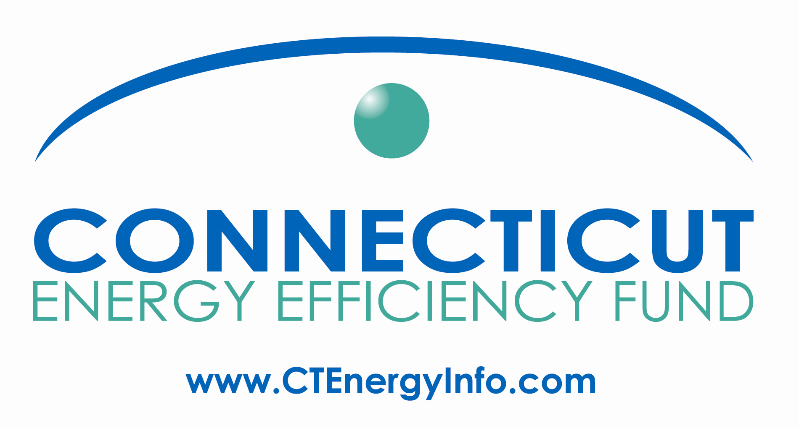
Agenda

Energy Efficiency Board
October 13, 2010, 9:00 pm -12:00 Noon
Department of Public Utility Control
10 Franklin Square, New Britain, CT 06051

Agenda for Two Meetings:

1.) Residential Committee of the EEB (formerly ECMB) Meeting: 9:00 (Sharp) - 10:50am
2.) HES Vendor Meeting 11:00 am - 12:00 Noon
Note: This is a new format of moving the Residential Committee meeting to early on the same morning that the HES Vendor meeting occurs. Both meetings are open to the public. You may join for either or both meetings, but we request that if you are joining us in person only for the HES Vendor meeting, that you wait until 10:50am to enter the room so as to minimize the disruption to the on-going Residential Committee meeting. (You may join the conference line at any time, but please keep your phone on Mute until it's appropriate for you to speak.) This is a trial format and we will revise it as necessary. Thank you.
Call in number: 1-800-655-1109 Id: 8758697 (note - we have had some telecom problems with the building in the past. If this line isn't going to work, we will distribute an e-mail by 9:05am)

Residential Committee:
1.) Update on Loan Program:
a.) update on current pilot (from the Companies)
-specific measures being financed in September
-YTD loan portfolio
b.) update on efforts to find new sources of funding (from the Companies):
i.) Option 1: shareholder capital - UI
ii.) Option 2: PA Trust
iii.) Progressive Energy and other efforts
c.) update on efforts to find new sources of funding and new administrative structure for all fuels solution (from VEIC)
2.) HES historical (2009? 2010?) actual savings per household per vendor (Companies' data anticipated to be ready to share by Sept 8th)
-Potential data base development to capture savings per household created by HES visit and/or follow-on measures (to include whether or not financing was utilized)
3.) N2N update
4.) Discussion of O-Power pilot

HES Vendors:
1.) Outstanding issues from last meeting not covered below:
· Companies will need to inform vendors if and when gas jobs are being covered by ARRA funds
· Companies will investigate Higher Ed requirements for training and distribute original e-mail from Susan Giordano
· Companies will investigate incentives for basement insulation further
· Vendors are encouraged to send a “trial balloon” of Davis Bacon compliance filings before they send their entire submission
2.) Follow-up on loan program
From last meeting:
· Companies will follow-up to schedule a meeting on the savings calculation tool and make sure that all vendors have a current version of the tool
-Vendors' experience with households in using the tool
· Vendors should provide suggestions as to what Companies should do to market the financing offer to customers.
· Companies' follow-up on availability of marketing materials from AFC
New topics:
· Are logistics working for getting households to sign permission during HES scheduling for utilities' to share household data with vendor?
· What are vendors' experience with households in their verbalized intentions of performing follow-on work? Is financing directly influencing those decisions?
· Update on interactions with non-HES vendors for HVAC or insulation installations. Do we need another venue for companies to meet each other?
3.) eeCommunities

From last meeting:
· Companies will provide eeCommunities contacts to vendors.
· Companies will schedule a follow-up discussion to better discuss how to coordinate with eeCommunities.
· Companies will distribute information on how vendors can participate in eeCommunities.
4.) Implications of 2011 plans on HES vendors
5.) Vendors' questions / concerns

